From http://elainemeinelsupkis.typepad.com/money_matters/2008/02/february-7-2008.html

The History of Seigniorage Wealth
February 7, 2008
Elaine Meinel Supkis
While reading the Scottish news today, I came across a seemingly obscure story which is all about fundamental, historical money-related things, 'Seigniorage'. The sovereign right to get a cut from every coin that is minted. This is still part of banking laws across the planet. Whenever a banking system and a government conspire to destroy the value of circulating currencies, the issue of seigniorage arises. For debasing paper also requires debasing the mint. When the US fell behind in this in the sixties, the melted coins in circulation were worth much more than their face value. When this happens, governments can go bankrupt if they don't remove the pure coins and replace them as fast as possible with debased coins. With paper, this is unnecessary, of course. They just print up paper with more 'zeros' on them. In modern times, the change is purely in bookkeeping data. What is a few trillion more zeros, anyway? Time to examine Greenspan's crimes.
Are Scottish notes in banks' or customers' interest?
SEIGNIORAGE. What an excellent word. Not one we see every day, though that is changing. Indeed, it is right at the heart of the outrage which has sprung up over the alleged threat to the much-loved Scottish banknote. I say alleged because, despite Alex Salmond's demands yesterday at First Minister's questions that everyone should rush to the barricades in defence of the Scottish note, it is not clear to me that it really is under threat.
In fact, this seems to be to be a classic producer versus consumer interest clash in which, in true Scottish tradition, the interests of consumers are being ignored in favour of those of producers which, in this case, are the big banks.
First the consumer interest, beginning with a little bit of history. The rights of Scottish (and Northern Irish) banks to issue their own notes was created in an 1845 act. This law was drawn up in response to a series of English banking collapses in which the holders of the collapsed bank's notes found they were worthless. To stop that, Westminster legislated to make all banks use Bank of England notes, which would keep their value regardless of commercial banks going bust.
Seigniorage certainly is interesting. It is the medieval word for 'top dog'. Or 'the nasty guy with the knights in tow who attacks anyone who defies him.' In other words, the Ruling Elites. Who were all, rather rough about things. They grew up hunting, killing and fighting...in person. Not like rulers today who are usually hidden well away from any battles. Let us not forget how many of them died: in armor. Like the famous Richard the Lionhearted. People forget how and why he died.
It seems that one of his knights in feof had, thanks to one of his serfs, dug up a treasure of gold buried when the barbarians swept over France during the collapse of the Roman Empire. The King of England was perpetually short of hard cash. Partially his own fault for leaving the Crusades. After insulting the proud Duke of Austria, the handsome Leopold Babenberger the Glorious, Richard then decided to go home via Vienna where the Duke lived.
This bizarre choice is remembered in many tales and songs. I suspect the King, a man of *ahem* certain desires probably was suffering from a Freudian moment of desire and couldn't help himself, being somewhat desirous to continue his confrontation with the very handsome but irritable Duke. Whose son was called 'Frederick the Irritable'. Heh. Well, the King of England had to be ransomed. So all the available gold and silver in England was the price. This led to the Magna Carta due to many irritable barons, dukes and lords ganging up on Richard's brother, John Lackland.
So, Richard came home, the King had to keep a bunch of barons happy, and he needed money. In classic fashion, he was stomping around France, looking for loot. When one of his own men found this treasure! Always, wealth and death are close to each other. Very close. As in this case. The baron offered a share to the King as his overlord. But Richard wanted all of it! So Richard rode to his own baron's castle and besieged it. While doing this, he was shot in the chest and died. So much for that.
John Lackland got the gold after the castle was stormed, the women were raped and everything there was destroyed. In turn, the other French barons, etc who were allied with the Throne of England decided to part ways and for the following 250 years, endless wars raged across France in this business which ended with the English losing everything. To this day, the English and French still insult each other. They also ignore whoever is running Vienna.
Back to modern times: the ancient laws and practices dating back to the re-emergence of money after vanishing in the Dark Ages still have the force of law and custom in our lands. The debate raging in gold-supporting sites online is all about seigniorage and who gets to determine the value of currency, who controls the mint and who gets to issue paper fiat debt documents against 'reserves.' Meanwhile, in the mainstream, all of this is totally ignored. All the pro-gold articles that quite accurately describe the mess we are in today all end on the same note: gold will fix this!
I, a close reader of history and as a person who has a mordant sense of humor, can't be so clear-minded and doctrinaire about all this. For history laughs as such notions! I even have had readers earnestly tell me, if we have gold as our basis for issuing paper money, there will be no wars!
This is pure insanity. Gold is a war magnet. Every bit as Helen launching a thousand ships, sex, gold and cattle have been traditional attractors of armed men seeking to rape, burn and steal. Indeed, in the Society for Creative Anachronism, I used to run a mercenary outfit of young males who fought with me in medieval armor on the battlefields for pay and loot. I used to line them up and have them repeat after me, 'FIRST you loot, THEN you rape and THEN you burn.' Then we would discuss how they couldn't rape anyone but had to ask permission and so on. And the loot was often rather hilarious items like toy sheep or stuffed dragons. And the burning were small bonfires which we stood around, drinking. We did once steal some pink flamingos from people out of Miami. Anyway, people actually paid us money to do these things.
The irritable relations with kings and queens who did whatever they wanted sometimes is all about the thorny hedge of laws and regulations concerning money. There are now, after 2,000 years, many restrictions and covenants concerning all this but this doesn't stop the looting and rapine. For example, the Church accumulated vast stores of wealth. Then one day, King Henry VIII, due to the total lack of any Jews to rape or loot, having lost control of all parts of France after England burned Joan of Arc at the stake, he had to have some loot so he looted the Church, itself! A classic move. Many of the laws of banking stem from this act, by the way. Even the Crown admits that this looting became the fundamental basis of the Bank of England and the enterprises which turned England into a naval power. That, in turn, led to piracy. Which is all about looting, raping and burning lots of things on the water as well as on land.
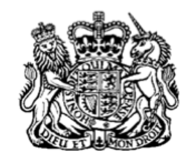
From Her Majesty's Home Page in England, the rules for banking set up under Queen Victoria:
Bank Notes (Scotland) Act 1845
In case it shall be made to appear to the [F1commissioners of inland revenue] , at any time hereafter, that any two or more banks have by written contract or agreement (which contract or agreement shall be produced to the said commissioners) become united subsequently to the passing of this Act, it shall be lawful to the said commissioners, upon the application of such united bank, to certify in manner herein-before mentioned the aggregate of the amount of bank notes which such separate banks were previously authorized to issue under the separate certificates previously delivered to them, and so from time to time; and every such certificate shall be published in manner herein-before directed, and from and after such publication the amont therein stated shall be and be deemed to be the limit of the amount of bank notes which such united bank may have in circulation, exclusive of an amount equal to the monthly average amount of the gold and silver coin held by such bank, as herein provided.
Ireland was slowly crawling out of the deep pit of deliberate starvation and the reduction of the population by nearly 1/3rd at this time. Scotland had been savaged in the previous 1,000 years of vicious fighting. The British rulers wanted Scotland to be friendly since it looked pretty nasty over in Ireland. So the Crown granted the banks of Scotland significant rights and privileges. Monetary policies are often political entities designed to cement power relationships. Just as rulers set up trade privileges or the right to collect duties and fees [the medieval word for feudalism comes from the word, 'fee']. Banking is merely an extension of the relationship between the rulers and the obligations, taxes, rents and levies which are required by the servile population.
In turn, the rulers have an obligation to defend all these people who are part of this system. We can see how this works in America. On 9/11, for example, all the fees and extractions which are very considerable, did absolutely nothing to protect us on that fatal day. When governments fail in their seignority, the value of currencies issued by them collapse. It is no shock, as a historian, to see the dollar rapidly dying after 9/11, for example. The Scottish banks, in this instance, could partake in the seigniorage of the mint which meant they could get a proportion of whatever monies they created. But they had to report to the new Bank of England which controlled how much and how often they got to do this.
The mechanism for this had to be controlled. No matter what one uses as 'money,' it cannot be overproduced or the money loses value via inflation. If you buy up a lot of copper, say, and make many pennies, the pennies already in circulation will lose value. A copper penny minted in the US back in 1950, when I was born, buys a lot less today than back then. The mineral that is the coin hasn't lost that much value but the penny as a DENOMINATED PART OF A PAPER DOLLAR has lost a lot of value. So much, people now melt pennies for the copper which is worth much more than the pennies, themselves. Since it costs money to mint pennies, the government banks are losing money by making pennies. They often talk about getting rid of pennies and making dollars the bottom most currency but hesitate because this then reveals how much the government has debased the mint. It is a paradox that the value of the mineral exceeds the inflationary destruction of the buying power of denominated coins. But then, this is a fact of life with paper fiat currency systems.
Historical periods when great amounts of mineral wealth are either discovered or looted or both cause currency and financial problems including tremendous inflation. Below is an article written a decade ago which is right on the eve of the Federal Reserve presiding over the biggest debasement of the dollar since the Bretton Woods II and Plaza Accords:
The debasement puzzle: an essay on medieval monetary history
From: Federal Reserve Bank of Minneapolis Quarterly Review | Date: 9/22/1997 | Author: Rolnick, Arthur J.; Velde, Francois R.; Weber, Warren E.
Debasement practices in England and France during the medieval ages have followed a similar pattern. First, there is an increase in both revenues and seigniorage rates. Second, both old and new coins were allowed to remain in circulation. Third, debasements were followed by large yet profitable minting volumes. Lastly, the intrinsic content of the coin was given primary importance over the legal tender value.
Sometimes, lest worse befall and to avoid scandal, a community tolerates dishonorable and evil things, like brothels. Sometimes also, by necessity or convenience, vile business is tolerated, like money-changing, or evil business, like usury. But there seems to be no reason on earth why so much gain should be allowed from alteration of the coinage for profit.
- Nicole Oresme(1)
In this article, we show that the experiences of France and England exhibit the following salient features. First, debasements were accompanied by unusually large minting volumes that yielded unusually large revenues for the sovereign. Second, during most debasements, seigniorage rates increased and revenues rose significantly. Third, both old and new coins circulated side by side following debasements. Finally, old and new coins were valued in circulation by their intrinsic content (circulation by weight) rather than by their legal tender value (circulation by tale). This last observation is well established for gold: silver seems to have circulated by weight in at least some instances.
In the medieval commodity money regime, only metal brought voluntarily to the mint was minted, and the mint retained a fraction of the metal - a charge known as seigniorage. In such a regime, large minting volumes following a debasement constitute a puzzle. Debasements are simply an opportunity offered to agents to voluntarily change heavy coins into light ones. If coins are valued in circulation for their intrinsic content, then debasements can provide no additional incentive to bring metal to the mint. Yet, debasements did in fact attract a lot of metal. The puzzle is compounded by the fact that the charge for coining usually increased considerably after a debasement.
Yes, that is a puzzle, isn't it? Of course, the reason people didn't mind turning over old coins or metals and getting the new ones back is quite simple: these people were usually either money-changers or lenders of money. So they got it FIRST. After it circulates, it buys less and less. But for the first people in line, the ones who handed over the metal and got the cheaper coins which were MORE, they had a temporary increase in buying power and since nearly all of them were landlords and collectors of rents, etc, they used this debased coin to PAY PEOPLE who they owed money to!
As a rule, if you can get a debased coin and then palm it off as a good coin to unsuspecting people, you make a profit. People collecting rents end up getting these debased coins back in debased form but they fix that via the simple mechanism of raising the rents or taxes or other extractions. Worse, the Crown as well as the barons would also set prices for things they wanted to control. So debased coins would buy the same things as before and the inflation would show up in odd ways, for example.
This is why the Crown had many bread rules. What went into bread, how much it weighed, its quality and price was all totally controlled by the government. This led to all sorts of problems like we have seen in communist nations, for example. Bread simply doesn't appear unless people do things to undo the inflationary problems besetting bakers. Indeed, the word 'Lord' comes from the word 'loaf of bread'. The lord controlled bread. This control was so intense, grinding of any grains with stone mills at home was strictly forbidden and anyone caught doing this was executed. And baking of bread was equally forbidden. The roots of modern banking are very entangled with the many laws and customs surrounding the creation and sale of breads and salt. For example, the word 'salary' comes from 'salt'.
Debasing the currency was very often popular with the people. The more coins the government minted, the easier it was to get these coins and in turn, pay off the seigniors. Peasants would far rather pay off their serfdom dues in coin rather than toil for a lord. Time is money and precious hours spent plowing, weeding and harvesting crops for the master meant far fewer hours tending one's own crops which brought in more wealth in times of inflation. So inflation increased the value of crops while easing the burden of paying off the lords who held the land in fee. This is why, except for people who can't raise prices for their labor, in general, debasement of the currency is very popular. Until the downside begins to show up. This is where the bubble/panic/depression comes in. Inflationary periods create bubbles and this, in turn, spawn a sudden panic, a collapse in price and then a depression. This is due to mother nature as well as world events. Always, when a drought/flood/pestilence reduces crops and people have to pay higher prices while not able to raise the price of all other goods, we get a collapse that can be very sudden.
The other thing that can be a killer is for the markets to be flooded by new gold or silver resources. This crashes the value of the money faster than the debasement can keep up. This forces people holding debased coins to see a serious decline in value as merchants demand purer gold content, for example.

By the late 13th century, all mints within a given political entity were under direct control of the sovereign. The mints were run as businesses by private entrepreneurs, who leased the physical plant and capital equipment for fixed terms. Individuals (goldsmiths and moneychangers) could come to a counter at the mint and deliver their metal (bullion, old coins, silverware, and goldware), and they would be paid back, within a few weeks, in newly minted coins of the same metal they brought in.(3) They always received back less fine metal than they brought in. Part of what was withheld by the mint paid for production costs and was called brassage. The rest was sent to the sovereign as profit, or tax, and was called seigniorage.
Today, the real power is no longer in the minting of any coins at all. The power is in Sovereign Wealth Funds. These are, unlike investors in the West, controlled by autocratic governments and distinct individuals have life and death power over these funds. This means they can put them to use in any way that pleases their fancies and unlike individuals seeking wealth, these people seek historic royal powers. That is, the power to choose where to park this wealth and how to make it grow or shrink. The West is madly working to centralize their banking/minting/sovereign wealth systems so a handful of individuals can use draconian powers over this so they can control global power. But this is very decentralized due to history and the US having the remains of a 'decentralized' system set up by the Founding Fathers that frustrates direct control over global finances and political power.
The Federal Reserve is struggling to create this and there are attempts at conspiring with Europeans to ditch the American system and replace it with a Louis XVI sort of dictatorship. Or an Emperor. Just as our Founding Fathers feared most. A Napoleonic centralization of power in the hands of an individual or group of Directores of the French Revolution, those fearsome men and women who run the guillotine day and night. It is no incidental chance that the most dynamic economic powers today on earth, the ones gathering the greatest Sovereign Wealth Funds happen to be former or present Communist Party nations.

Crying-up, or enhancement, raises the LTV [loan-to-value] of an existing coin holding C fixed. Crying-down lowers the LTV. When it is set to zero, the coin is decried and ceases to be legal tender. Such changes are a matter of mere decree.
A decrease in C is called debasement.(5) An increase is called reinforcement. Debasement can occur in two ways: by alteration of an existing coin or by introduction of a new coin with a new type and a higher ME. Both methods were used in the Middle Ages, but even when the existing coinage was altered, a change in fineness or even in weight was indicated by a small change in the design of the coin.(6) Reinforcements always occurred with the introduction of a new coin, usually distinctive and with high fineness.
As far as we know, metal was brought to the mint voluntarily, even during periods of debasement. This was explicitly true for the Great Debasement.(7) Measures such as the compulsory melting of tableware or demonitization of coins were sometimes taken to mandate reminting. (See Landry 1910, p. 109, n. 4.) But it is doubtful that the sovereign had much power to enforce these measures.
The Fed mentions the same facts as in the previous article. About how people brought in money for debasement. Many a sovereign had to resort to forcing debasement. When this happens, far from not having the power to compel this, there most certainly WAS such powers! And they were used, with tremendous brutality. As with hunting animals, the sovereign would not dare hammer everyone at the same time, far from it.
UNIVERSALLY, they target a minority. In the majority of cases, Jews. But in Catholic lands, after 1600, it would be Protestant minorities like my ancestors in Paris, and in Protestant land, the victims were Jews, Catholics, Irish or WITCHES. Yes, them too. The fact is, when silver and gold poured into Europe and inflation raged and the war extractions by the ruling elites rose rapidly, we see a sudden surge in witch hunting as well as the despoiling of most of the Jewish communities. Informers would get a cut of the loot if they told the Crowns where gold or silver was being hidden! Soldiers would storm houses and loot, rape and burn. As always. And the power to do this is the power of the Sovereign. The Seignior. The noble directing these horrors would carefully catalogue the loot and the sovereign would then carefully weigh their own share. This made life very dangerous and this is an important impulse that drove many people to the New World, such as my fractious ancestors. Who came up with the concept of 'freedom' and even more importantly, 'A man's home is his castle'. Actually, in England, our homes were castles.
Back to the Fed's history lesson:
Compared to France, England enjoyed monetary stability. While debasements occurred for both silver and gold during the 14th and 15th centuries, they were far less frequent than in France. Seigniorage rates always remained low, debasements occurred at long intervals, and the pound sterling never lost more than 20 percent at a time. This reign of monetary stability ended with the Great Debasement. From 1542 to 1551, silver or gold was debased ten times, and the pound sterling lost 83 percent of its silver content. The gross seigniorage rate went from 2 percent to 57 percent. Yet the volume of minting was so large that the single mint at the Tower of London was not enough, and the sovereign had to open six new mints.
Anyone who imagines metal prevents inflation should read the above paragraph and then memorize it. Just like printing money like mad is lots of work, ditto for the mint! And if there is sufficient paper/metal pouring into the system, the minters simply work more hours and more are hired. The bakers may complain bitterly but the renters are happy so long as they can demand pay raises. When that ends, the misery really begins. But for a few years, in this case around 10, it is lucrative and fun. Indeed, most inflationary periods have about 10 years of grace before the crash hits. As we can see today.
Here is a timeline for this period in history:
*1500-1540: Huge supplies of New World gold reach Spain
On average between 1,000 and 1,500 kg. of gold reach Spain each year during this period. Initially these supplies are obtained by plunder, especially from the Aztecs and Incas, and later by applying new mining methods [Elaine: and lots of native and then African slaves] to the New World gold deposits.
*1526: Nicholas Copernicus writes his Treatise on Debasement
With many provinces of his native Poland, and other parts of Europe, suffering from debasement the great astronomer argues that it is the total number of coins in circulation, rather than the weight of metal they contain, that determines the level of prices and the buying power of the currency. [Elaine: and then they burned him at the stake for being a witch!]
*1540-1640: The Price Revolution in Europe
Europe, including Britain, experiences a prolonged period of inflation, partly because of the huge influx of gold and silver from the Spanish colonies in America and partly because the increase in population is not matched by an increase in the output of the economy.
*1542-1551: The Great Debasement
Henry VIII debases the coinage of England as a means of raising revenue. In Ireland the debasement started earlier, in 1536, and does not finish until 1560.
*1545: Henry VIII legalises interest charges on loans
An upper limit of 10% per annum is set. [Elaine: credit card companies would be hung back then for usury!]
*1597: Spanish exports of silver to China reach a peak
In this year 345,000 kg. of Peruvian/Bolivian and Mexican silver are shipped from Acapulco to China via Manilla. [Elaine: the ancient directional flow of wealth has finally returned this last 5 years after 200 years of flowing from China to Europe]
If the gold and silver in the New World did NOT flow to China, Europe's economies would have collapsed due to the value of gold and silver dropping disastrously. As it was, the flood was too great and the burden of this destroyed Spain and Portugal. Both dealt with this flood of wealth by invading the Netherlands which is where banking was the center of gravity. And the battle between the people flooding Europe with gold and silver versus the bankers creating wealth via LENDING MONEY was very brutal, extremely destructive and dragged in all the surrounding nations and was mixed in with religion as this was also a vicious religious war and in all this, the country with the ability to create LOANS WON THE WARS! The Dutch, using the ability to create modern banking, utterly bankrupted Spain. I hope everyone understands the import of all this. It is no trivial matter.
The Jews, chased out of Spain, moved to the Netherlands and worked alongside the bourghers [Dutch: middle class towns people] to create the fundamentals of modern banking and bookkeeping. And the Spanish didn't have this. They were much more medieval. Whereas the Dutch were modern. The Spanish were burning intellectuals for being witches while the Dutch were giving them stipends so they could teach. The US today should heed the lessons of the past. Instead of running a modern banking system, we are falling into the trap the Japanese fell into: expanding power while destroying the ability to generate endless wealth creation via the fundamentals of compound interest banking is a dangerous thing that will destroy us.
Time to go to some old New York Times papers from the 19th century, during the 1893 Panic, the time when an ancestor of mine shot himself in despair:
November 15, 1893:
PROFITS OF THE SEIGNIORAGE.; The Coinage of Silver Dollars Not Yet Begun.
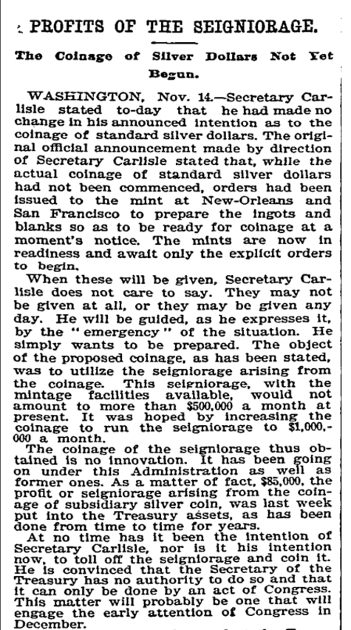
***********************************************************
The 'emergency' here is the bubble breaking, a panic ensuing and a depression growing. Note how the government hopes to make a million dollars profit minting coins. And how this can't be exactly announced. Note the deliberate uncertainty in the announcement. This is a futile attempt at trying to control speculators who flock around this seigniorage events. Just as we see today.
March 14, 1894:
AGAINST SEIGNIORAGE ACT; OPPOSED BY NEW-YORK BANKERS AND MERCHANTS.
They Have Faith in President Cleve- land's Consistency and Do Not Be- lieve that He Will Approve the Bill -- It Ought Not to Become a Law Under Any Consideration -- Opinions of Charles S. Smith, John A. McCall, Abram S. Hewitt, and Others
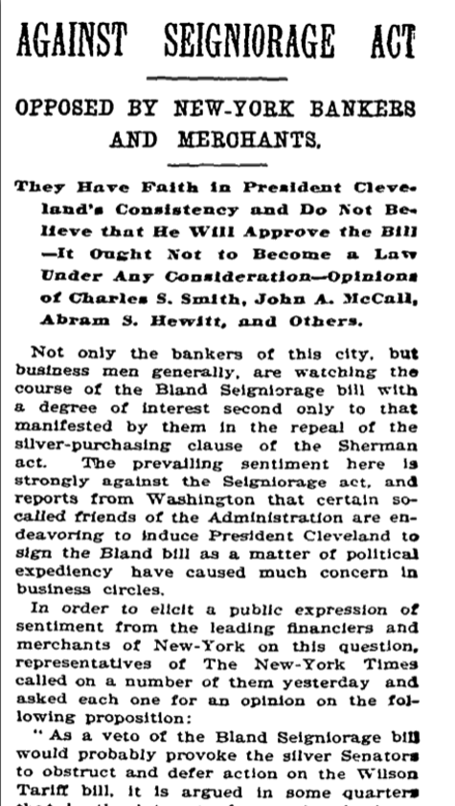
***********************************************************
Eastern establishment bankers with relations in Europe were against all this. They benefited by a reduction in the availability of coinage. They knew the real source of wealth was the creation of LOANS, not minting mineral coins. The minting of millions of dollars of coins a month would reduce the value of their portfolio of LOANS. So they wanted that controlled as much as possible just as the landlords of yore wished to keep the coinage under control so the tenants had as few as possible.
Click on news paper report to enlarge:
March 8, 1894:
TARIFF HAS NO BARRIER NOW; OBSTRUCTING SENATORS TRAPPED BY THE SEIGNIORAGE BILL.
Their Plan Was to Prolong Discussion and Prevent Consideration of the Tariff -- By Clever Tactics the Bill Passed Its Third Reading and No Amendments Can Now Be Asked -- Coinage Bill May Be Quickly Passed, Perhaps, To-day
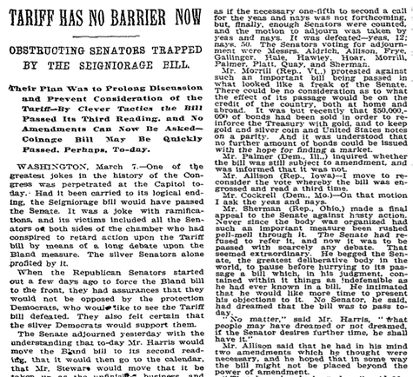
********************************************************
Note that this article is about debates concerning tariffs and barriers set to protect domestic markets. And the reporter gives a detailed accounting of the parliamentary games in the Senate. And the difficulty of keeping silver and gold to some sort of parity is important here. Even as the gold rush in Alaska was just about to flood the US with more gold, the Senators were debating how to bring more gold into the Treasury. Indeed, all panics/depressions feature attempts at gaining more gold to make up for the collapse in lending. Today we see a different program but it is essentially the same in the end: more 'money' is pumped into flagging banks to keep them solvent when their loans go in arrears.
Remarks by Chairman Alan Greenspan
At the U.S. Treasury Conference on Electronic Money & Banking: The Role of Government, Washington DC
9/19/1996 [Elaine: a magic number day, by the way!]
Our optimum financial system is one of free and broad competition that is presumed to calibrate appropriately the changing value of products to consumers so that the risk-adjusted rate of return on equity measures the success in providing what people want to buy. [Elaine: HAHAHA. He sounds like the bread quality/price controller of the Royal Purse in 1300 AD England!]
This has turned out to be broadly true in practice and supplied regulators with some sense of which products were serving consumers most effectively. This signal may not be so readily evident in the case of electronic money. The problem is seigniorage, that is, the income one obtains from being able to induce market participants to employ one's liabilities as a money. Such income reflects the return on interest-bearing assets that are financed by the issuance of currency, which pays no interest, or at most a below-market rate, to the holder. [Elaine: obviously, the profits to the Crown are via getting a 'cut' of the metal before minting!]
Historically when private currency was widespread, banks garnered seigniorage profits. This seigniorage increasingly shifted to the federal government following the National Bank Act, when the federal government imposed federal regulation on bank note issuance, taxed state bank notes, and ultimately became the sole issuer of currency. [Elaine: indeed, the power of the State, able to intercept all wealth and control it via the power of the sword or gun!]
Today, there continue to be incentives for private businesses to recapture seigniorage from the federal government. Seigniorage profits are likely to be part of the business calculation for issuers of prepaid payment instruments, such as prepaid cards, as well as for traditional instruments like travelers checks. As a result, in the short term, it may be difficult for us to determine whether profitable and popular new products are actually efficient alternatives to official paper currency or simply a diversion of seigniorage from the government to the private sector. Yet we must also recognize that a diversion of seigniorage may be an inevitable byproduct of creating a more efficient retail payment system in the long run. [Elaine: My god. This man is totally insane and so are his buddies in the Miltonian universe! They certainly let privateers recapture seigniorage! This is why I call this swarm of raptors 'pirates' and do note that they are rapidly and busily moving our sovereign wealth offshore to pirate coves in the Caribbean!]
The innovations being discussed today can be viewed from a very different perspective than that afforded by the financial system of the 1850s. Unlike the earlier period, we have a well developed and tested set of monetary and payment arrangements and a strong national currency. Yet, as in the earlier period, industry participants may find that self-policing is in their best interest. We could envisage proposals in the near future for issuers of electronic payment obligations, such as stored-value cards or "digital cash," to set up specialized issuing corporations with strong balance sheets and public credit ratings. Such structures have been common in other areas, for example, in the derivatives and commercial paper markets. [Elaine: ARREST GREENSPAN! ARREST BERNAKE! ARREST THEM ALL! Good grief, note how the privateers who have taken away our government's seigniorage have now debased our currency which has been collapsing even as our trade partners desperately park much of this excess away in their own sovereign wealth funds?]
In conclusion, electronic money is likely to spread only gradually and play a much smaller role in our economy than private currency did historically. Nonetheless, the earlier period affords certain insights on the way markets behaved when government rules were much less pervasive. These insights, I submit, should be considered very carefully as we endeavor to understand and engage the new private currency markets of the twenty-first century. [Elaine: talk about a very stupid man! Greenspan thought, just 10 years ago, electronic money wasn't a genie let out of a bottle? It can go to INFINITY and has been doing everything possible to accomplish this. As Evil Kerviel noted, 'the Sky is the Limit, man!']
These past words condemn Greenspan as a fool, a knave and a total idiot. He, unlike myself, is well educated and supposedly, aware of history. His little experiment in the destruction of our nation's sovereignty is TREASON. No ifs, ands or buts! And a very serious crime, indeed. We are now in the grips of an obvious bubble/panic/depression event and the Federal Reserve is trying to fix this by despoiling our currency and destroying our seigniority. And since the rising power in China, the former destination of previous minted monies is now the foremost sovereign wealth power on earth, the handing over of our entire banking system to a bunch of crazy pirates in the Caribbean is the biggest betrayal of America's economic system since the Founding Fathers. If not in all the history of finance since Caligula!

